|  |
| --- |
| Shahjalal University of Science and Technology, Sylhet. |
| A short document on |
| IT support for office management |
|  |
| **By Nusrath Jahan Lupa** |
| **Year 2024** |

|  |
| --- |
|  |

**IT TECHNICAL SUPPORT DEPARTMENT:**

Types of IT Support Services by Level  
IT support is tailored to the needs of the specific company. Here is an overview of the different tech support Levels and types of support you can expect to receive from each.  
  
**Level 0 - Self help**

At this level, users can retrieve support information themselves, typically involving minimal assistance from an IT professional. This involves running search queries, pulling information from websites, FAQs, technical manuals, blog posts, app pages, service catalogs, knowledge base articles, and potentially even chat bots**.**

**Level 1 – Help Desk / Service Desk**  
This is your first line for direct tech support. These are your Helpdesk Operators, IT Call Desk support, First Line Support Engineers, and First-Line Network Support Analysts. Users interact through the phone or web (sometimes chat only) with an IT professional and then receive support for basic issues, known problems, and service requests. Your first-line support provider should have a broad range of general knowledge. This will allow them to quickly resolve most basic user problems so the user can get back up and running with minimal downtime. The service desk technician may use [remote support technology](https://www.beyondtrust.com/remote-support) to take remote control of your computer at this stage.

**Level 2 – Technical Support**  
Level-two technical IT support will have more in-depth, specialized knowledge and experience with the product or service that aligns with the incident. They are most likely to be Second-Line Support Engineers, Customer Support Technicians, and Desktop Support Analysts. Typically, the incidents addressed at this level require more technical expertise. Having [the right IT support certifications](https://www.beyondtrust.com/blog/entry/5-must-have-certifications-for-support-professionals) in this scenario is a must. Here, your technical support personnel will assess the issue and provide a solution. This process may entail multiple conversations between the technical IT support technician and the client. IT services may need to take remote access control to fix the problem.

**Level 3 – Expert Product and Service Support**This is where the highest technical resources are accessed for incident resolution. These support staff are the most highly skilled product and service specialists, including Network Specialists, Server Engineers, Third-Line Support Engineers, and the engineers, programmers, and even the chief architects who created the product or service. They will attempt to duplicate the problem to define the root cause and issue a new fix. Once the fix is issued, it will be documented for future use by Level-one and -two customer support technicians.

**Level 4 – Outside Support**  
  
Level four IT support involves preferred vendors and business partners who are contracted from outside the organization to provide support for items that are not directly serviced by the organization. This might include things like printer support, vendor software support, machine maintenance, and depot support.

**What types of issues are resolved by IT support?**  
1. Troubleshooting hardware, software, server maintenance, and other tech issues  
  
Most offices now require employees to access multiple different hardware and software tools during day-to-day operations. Tech support teams will help ensure servers remain operational and properly maintained. They will also ensure that any endpoints and applications are operating properly to avoid interference with efficiency or uptime.

2. Viruses, malware, security breaches  
  
IT support is the frontline defense for implementing [cyber security solutions](https://www.beyondtrust.com/resources/glossary/cyber-security) that can prevent cyber-attacks and mitigate the risk when a breach does occur. Such support activities include:  
Performing network monitoring and security - controlling access to a business’s network by issuing and removing authorization as needed, building firewalls, installing antivirus software, installing VPNs, updating security patches, and performing regular network checkups.

3. Data backups  
Your service desk may manage the information backup services that protect your business in the event of a breach, power outage, or system failure. They may manually or automatically run file backups, server backups, and even desktop backups. They will also test back-up sets to make sure the information can be recovered in its entirety. This protects against information loss and ensures data security. For instance, in the event of a breach, a secure backup can help jumpstart operations. Data backups can be managed:

* In the Cloud
* On-premises servers
* Off premises servers
* Hybrid/combination

4. Password Recovery and Access issues  
  
These can impact internal- or external-facing IT customers. Let’s face it, everyone has a lot of passwords to remember. A help desk technician can help when an employee can’t get logged into their PC, email account, etc. They can reinstate user rights or reset your password for you if the problem was as straightforward as a forgotten password. If there is something more complex going on, they can investigate and provide a solution.

Why IT technical support is the future of customer service?  
   
Majority of the companies in software and telecom domain have now discovered the option of fetching the advice from the expert on IT technical support at a fraction of the price they usually were changed with the advantage of the skilled resources who speak the same language as theirs.

**Emerging IT Infrastructure and Technologies:**

Learning objectives:

* What is IT infrastructure and what are the stages and drivers of IT infrastructure evolution?
* What are the components of IT infrastructure?
* What are the current trends in computer hardware platforms?
* What are the current trends in computer software platforms?
* What are the challenges of managing IT infrastructure and management solutions?
* **IT infrastructure:**
  + **Set of physical devices and software required to operate enterprise**
  + **Set of firm wide services including:**
    - Computing platforms providing computing services
    - Telecommunications services
    - Data management services
    - Application software services
    - Physical facilities management services
    - IT management, education, and other services
  + **“Service platform” perspective**
    - More accurate view of value of investments

***CONNECTION BETWEEN THE FIRM, IT INFRASTRUCTURE, AND BUSINESS CAPABILITIES***

The services a firm is capable of providing to its customers, suppliers, and employees are a direct function of its IT infrastructure. Ideally, this infrastructure should support the firm’s business and information systems strategy. New information technologies have a powerful impact on business and IT strategies, as well as the services that can be provided to customers.

**IT Infrastructure**

* **Evolution of IT infrastructure**
  + **General-purpose mainframe and minicomputer era: 1959 to present**
    - 1958: IBM first mainframes introduced
    - 1965: Less expensive DEC minicomputers introduced
  + **Personal computer era: 1981 to present**
    - 1981: Introduction of IBM PC
    - Proliferation in 80s, 90s resulted in growth of personal software
  + **Client/server era: 1983 to present**
    - Desktop clients networked to servers, with processing work split between clients and servers
    - Network may be two-tiered or multitiered (N-tiered)
    - Various types of servers (network, application, Web)
* **Evolution of IT infrastructure (cont.)**
  + **Enterprise computing era: 1992 to present**
    - Move toward integrating disparate networks, applications using Internet standards and enterprise applications
  + **Cloud and mobile computing: 2000 to present**
    - Cloud computing: computing power and software applications supplied over the Internet or other network
      * Fastest growing form of computing

**Technology drivers of infrastructure evolution:**

* + **Moore’s law and microprocessing power**
    - Computing power doubles every 18 months
    - Nanotechnology:
      * Shrinks size of transistors to size comparable to size of a virus
  + **Law of Mass Digital Storage**
    - The amount of data being stored each year doubles

**IT Infrastructure has seven main components**

* 1. **Computer hardware platforms**
  2. **Operating system platforms**
  3. **Enterprise software applications**
  4. **Data management and storage**
  5. **Networking/telecommunications platforms**
  6. **Internet platforms**
  7. **Consulting system integration services**

THE IT INFRASTRUCTURE ECOSYSTEM

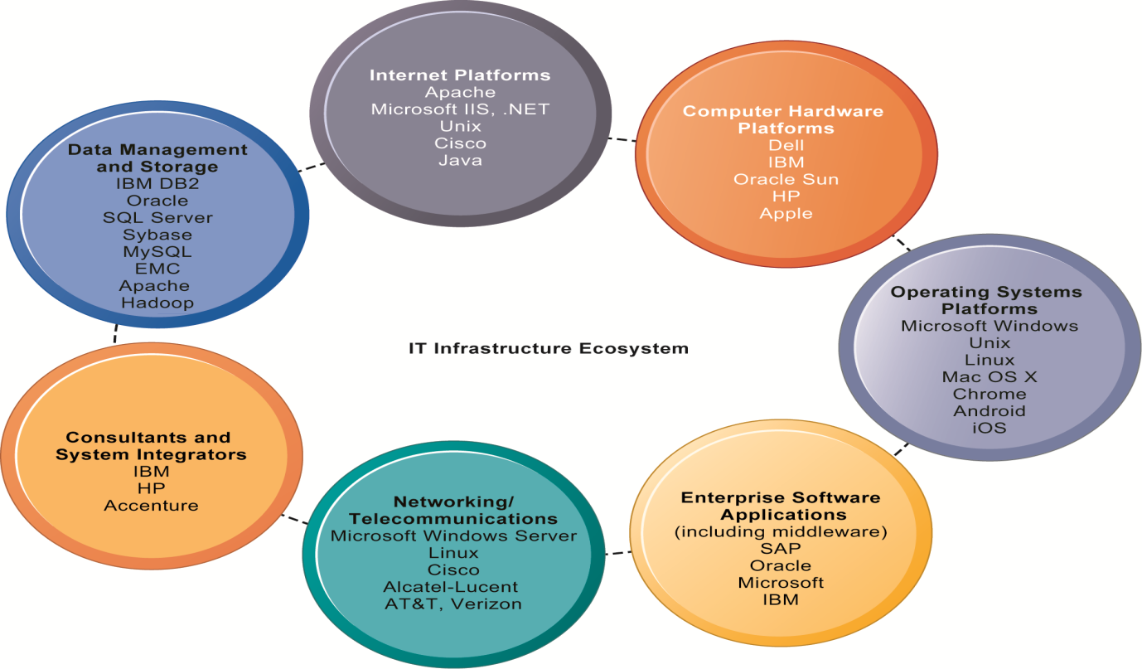

**Technology drivers of infrastructure evolution (cont.)**

* + **Standards and network effects**
    - Technology standards:
      * Specifications that establish the compatibility of products and the ability to communicate in a network
      * Unleash powerful economies of scale and result in price declines as manufacturers focus on the products built to a single standard

**IT Infrastructure Components:**

* **Computer hardware platforms**
  + **Client machines**
    - Desktop PCs, laptops
    - Mobile computing: smartphones, tablets
  + **Servers** 
    - Blade servers: ultrathin computers stored in racks
  + **Mainframes:**
    - IBM mainframe equivalent to thousands of blade servers
  + **Top chip producers: Intel, AMD**
* **Operating system platforms**
  + **Operating systems**
    - Server level: 65% run Unix or Linux; 35% run Windows
    - Client level:
      * 90% run Microsoft Windows (Windows 8, Windows 7, etc.)
      * Mobile/multitouch (Android, iOS)
      * Cloud computing (Google’s Chrome OS)
* **Enterprise software applications**
  + Enterprise application providers: SAP and Oracle
  + Middleware providers: IBM, Oracle
* **Data management and storage**
  + **Database software:** 
    - IBM (DB2), Oracle, Microsoft (SQL Server), Sybase (Adaptive Server Enterprise), MySQL
  + **Physical data storage:** 
    - EMC Corp (large-scale systems), Seagate, Western Digital
  + **Storage area networks (SANs):** 
    - Connect multiple storage devices on dedicated network
* **Networking/telecommunications platforms**
  + **Telecommunication services**
    - Telecommunications, cable, telephone company charges for voice lines and Internet access
    - AT&T, Verizon
  + **Network operating systems:**
    - Windows Server, Linux, Unix
  + **Network hardware providers:** 
    - Cisco, Alcatel-Lucent, \Juniper Networks
* **Internet platforms**
  + Hardware, software, management services to support company Web sites (including Web-hosting services), intranets, extranets
  + Internet hardware server market: IBM, Dell, Sun (Oracle), HP
  + Web development tools/suites: Microsoft (Visual Studio and .NET), Oracle-Sun (Java), Adobe, Real Networks
* **Consulting and system integration services**
  + Even large firms do not have resources for full range of support for new, complex infrastructure
  + Leading consulting firms: Accenture, IBM Global Services, HP, Infosys, Wipro Technologies
  + Software integration: ensuring new infrastructure works with legacy systems
  + Legacy systems: older TPS created for mainframes that would be too costly to replace or redesign

**Current Trends in Hardware Platforms**

* **The mobile digital platform**
  + **Smartphones (iPhone, Android, and Blackberry)** 
    - Data transmission, Web surfing, e-mail, and IM
  + **Netbooks:** 
    - Small lightweight notebooks optimized for wireless communication and core tasks
  + **Tablets (iPad)**
  + **Networked e-readers (Kindle and Nook)**
  + **Wearable devices (smart watches, smart glasses)**
* **Competitive forces model for IT infrastructure investment**
  1. Market demand for firm’s services
  2. Firm’s business strategy
  3. Firm’s IT strategy, infrastructure, and cost
  4. Information technology assessment
  5. Competitor firm services
  6. Competitor firm IT infrastructure investments

***COMPETITIVE FORCES MODEL FOR IT INFRASTRUCTURE***

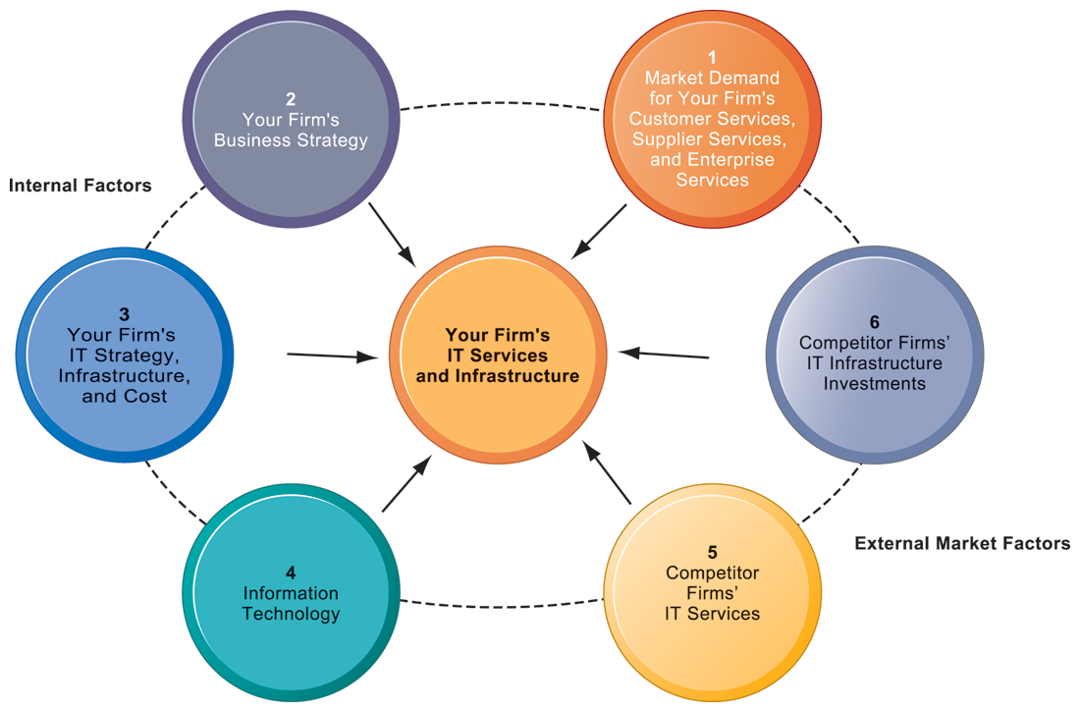

There are six factors you can use to answer the question, “How much should our firm spend on IT infrastructure?”